composer init

🛠️ What Does composer init Do?
# Source: AI Source: Provided by: [Data Path: Persons Table -> ID Column: 1, Name_En Column: Motasem Essam] -> From: [Chatgpt (GPT‑5 Mini)] on [1/26/2026]
The command:


composer init

Creates a new composer.json file for your PHP project by guiding you through a step-by-step interactive setup.

📋 What It Does
# Source: AI Source: Provided by: [Data Path: Persons Table -> ID Column: 1, Name_En Column: Motasem Essam] -> From: [Chatgpt (GPT‑5 Mini)] on [1/26/2026]
- Asks you questions like:
  - 📛 Package name (e.g. yourname/project)
  - 📝 Description
  - 🏷️ License
  - 👤 Author info
  - 💾 Dependencies (libraries you want to require)
- Then generates a ready-to-use composer.json

✅ When to Use composer init
# Source: AI Source: Provided by: [Data Path: Persons Table -> ID Column: 1, Name_En Column: Motasem Essam] -> From: [Chatgpt (GPT‑5 Mini)] on [1/26/2026]
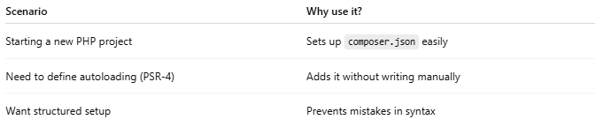

Scenario | Why use it?
Starting a new PHP project | Sets up composer.json easily
Need to define autoloading (PSR-4) | Adds it without writing manually
Want structured setup | Prevents mistakes in syntax

📌 What to Do After
- Add classes in your defined folder (src/, for example)
- Run:
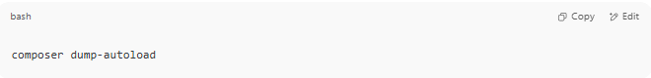
composer dump-autoload

- Include the autoloader in your code:
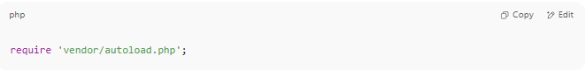
require 'vendor/autoload.php';

Guide Steps

1. Create folder
# Source: AI Source: Provided by: [Data Path: Persons Table -> ID Column: 1, Name_En Column: Motasem Essam] -> From: [Chatgpt (GPT‑5 Mini)] on [1/26/2026]
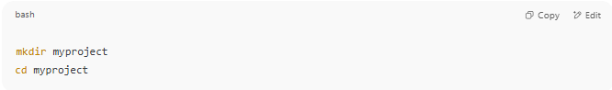
mkdir myproject
cd myproject

2.composer init
# Source: AI Source: Provided by: [Data Path: Persons Table -> ID Column: 1, Name_En Column: Motasem Essam] -> From: [Chatgpt (GPT‑5 Mini)] on [1/26/2026]
Then inside the folder:
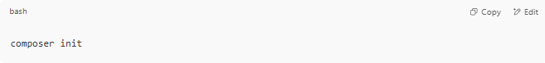
Just press Enter for defaults.

🧾 1. Package Name
# Source: AI Source: Provided by: [Data Path: Persons Table -> ID Column: 1, Name_En Column: Motasem Essam] -> From: [Chatgpt (GPT‑5 Mini)] on [1/26/2026]
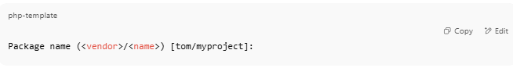Package name (<vendor>/<name>) [tom/myproject]:

This should follow the format:
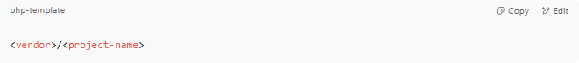
<vendor>/<project-name>

✅ Example:
- omar/myproject
- webtools/contact-api
🔸 The vendor is usually your GitHub username, organization name, or your name in lowercase.
🔸 The name is your project folder name or app name (also lowercase, no spaces).
You can press Enter to accept the default:
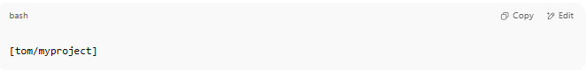
[tom/myproject]

Or type your own:
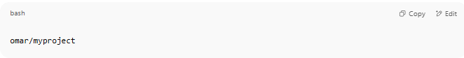
omar/myproject

📝 2. Description
# Source: AI Source: Provided by: [Data Path: Persons Table -> ID Column: 1, Name_En Column: Motasem Essam] -> From: [Chatgpt (GPT‑5 Mini)] on [1/26/2026]
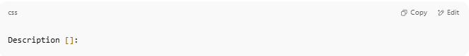
Description []:

This is a short summary of what your project does. It helps other developers understand your package if it’s shared or published later.
✅ Examples:
- A simple PHP API for managing users
- My first PHP web project using Composer
- RESTful web service for managing contacts
- Lightweight blog backend built with PHP
You can also leave it blank by just pressing Enter.

👤3. Author
# Source: AI Source: Provided by: [Data Path: Persons Table -> ID Column: 1, Name_En Column: Motasem Essam] -> From: [Chatgpt (GPT‑5 Mini)] on [1/26/2026]
This is where you define who created the package. It uses this format: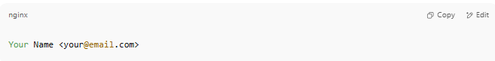

✅ Examples:
- Omar Ali <omar@example.com>
- Web Dev <webdev@gmail.com>
If you're okay with the existing default:
Just press Enter.

❌ To skip:
Type:
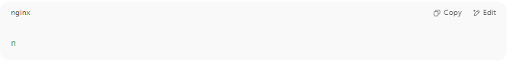
n

🔐 4. Minimum Stability
# Source: AI Source: Provided by: [Data Path: Persons Table -> ID Column: 1, Name_En Column: Motasem Essam] -> From: [Chatgpt (GPT‑5 Mini)] on [1/26/2026]
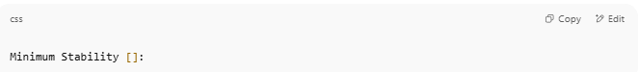
Minimum Stability []:

This tells Composer what level of package stability you're willing to accept when installing dependencies.
🏷️ Stability Levels:
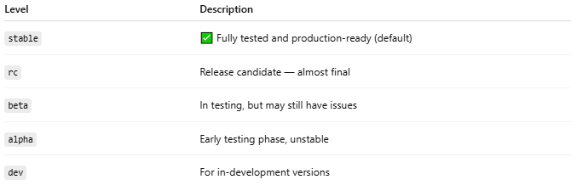

Level | Description
stable | ✅ Fully tested and production-ready (default)
rc | Release candidate — almost final
beta | In testing, but may still have issues
alpha | Early testing phase, unstable
dev | For in-development versions

✅ Recommended:
If you're building a production app, use:
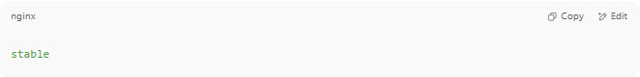
stable

If you're developing and want to try newer or experimental packages, use:

dev

💡 Default:
If you just press Enter, it defaults to stable.
You can still override stability per package later in composer.json.

📦 5. Package Type
# Source: AI Source: Provided by: [Data Path: Persons Table -> ID Column: 1, Name_En Column: Motasem Essam] -> From: [Chatgpt (GPT‑5 Mini)] on [1/26/2026]
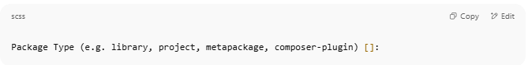
Package Type (e.g. library, project, metapackage, composer-plugin) []:

This defines what kind of package you're creating. Composer uses this to understand how your package should behave.

🧾 Common Types:
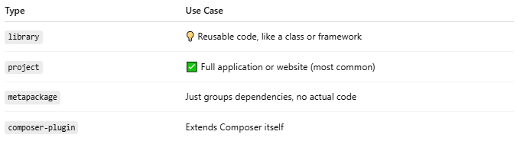

✅ For most PHP apps:
Use:
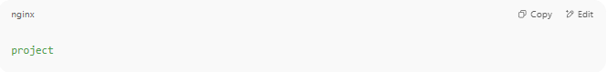
project

If you're creating an app or website (not a reusable library), project is the correct choice.

🧠 You can leave it blank
If you press Enter, Composer won't assign a type — but it's better to specify one for clarity.

📄 6. License
# Source: AI Source: Provided by: [Data Path: Persons Table -> ID Column: 1, Name_En Column: Motasem Essam] -> From: [Chatgpt (GPT‑5 Mini)] on [1/26/2026]
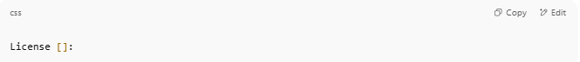
License []:

This defines the terms under which your code can be used. Composer uses it to let others know how they can legally use or share your project.

✅ Common Licenses:
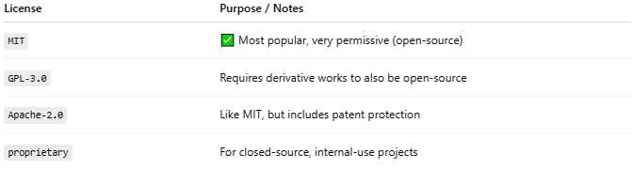

License | Purpose / Notes
MIT | ✅ Most popular, very permissive (open-source)
GPL-3.0 | Requires derivative works to also be open-source
Apache-2.0 | Like MIT, but includes patent protection
proprietary | For closed-source, internal-use projects

📌 Recommendation:
If you're just experimenting or want to share openly:

MIT

If you're building something private or not for sharing: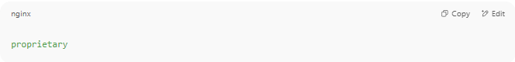
proprietary

❌ You can skip it:
Just press Enter to leave it blank for now.

⚙️ 7. Define Your Dependencies
# Source: AI Source: Provided by: [Data Path: Persons Table -> ID Column: 1, Name_En Column: Motasem Essam] -> From: [Chatgpt (GPT‑5 Mini)] on [1/26/2026]
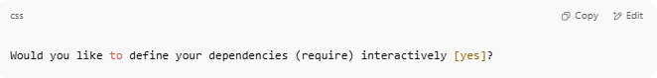
Would you like to define your dependencies (require) interactively [yes]?

This step lets you add PHP packages your project needs — like libraries or frameworks.

✅ Options:
- Type yes or press Enter → Composer will ask you to type the package names.
- Type no if you want to skip for now and add them later manually using composer require.
🧾 Examples of Common Packages:
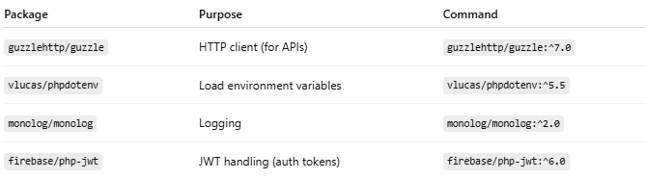

Package | Purpose | Command
guzzlehttp/guzzle | HTTP client (for APIs) | guzzlehttp/guzzle:^7.0
vlucas/phpdotenv | Load environment variables | vlucas/phpdotenv:^5.5
monolog/monolog | Logging | monolog/monolog:^2.0
firebase/php-jwt | JWT handling (auth tokens) | firebase/php-jwt:^6.0

🔍 Example Workflow (if you choose yes):
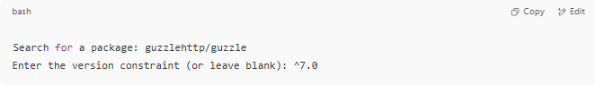
Search for a package: guzzlehttp/guzzle
Enter the version constraint (or leave blank): ^7.0

Repeat for each package you want to add.

📦 If you’re not sure now:
Just type:
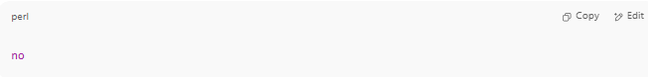
no

You can always add packages later using:
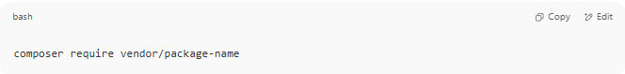
composer require vendor/package-name

🧪 8. Define Development Dependencies
# Source: AI Source: Provided by: [Data Path: Persons Table -> ID Column: 1, Name_En Column: Motasem Essam] -> From: [Chatgpt (GPT‑5 Mini)] on [1/26/2026]

Would you like to define your dev dependencies (require-dev) interactively [yes]?

These are packages needed only during development, not in production.
✅ You can say:
- yes → Composer will ask you to add tools like testing frameworks or linters.
- no → Skip for now; you can add them later with composer require --dev.
🧾 Common Dev Dependencies
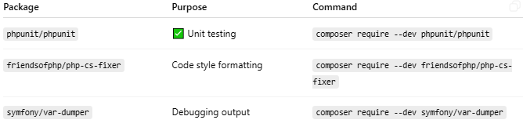

Package | Purpose | Command
phpunit/phpunit | ✅ Unit testing | composer require --dev phpunit/phpunit
friendsofphp/php-cs-fixer | Code style formatting | composer require --dev friendsofphp/php-cs-fixer
symfony/var-dumper | Debugging output | composer require --dev symfony/var-dumper
❌ If you're unsure now:
Just type:
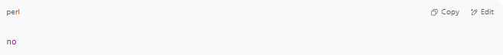
no

📚 9. PSR-4 Autoload Mapping
# Source: AI Source: Provided by: [Data Path: Persons Table -> ID Column: 1, Name_En Column: Motasem Essam] -> From: [Chatgpt (GPT‑5 Mini)] on [1/26/2026]
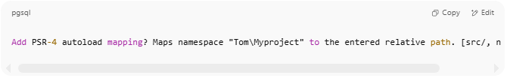
Add PSR-4 autoload mapping? Maps namespace "Tom\Myproject" to the entered relative path. [src/, n to skip]:

This tells Composer how to autoload your PHP classes using PSR-4 — a standard for organizing and loading class files.

✅ What It Means:
If you choose the default:
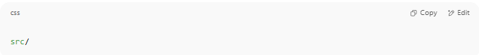
src/

Then any class like:
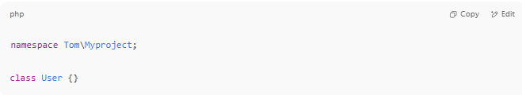
namespace Tom\Myproject;

class User {}

Should be placed in: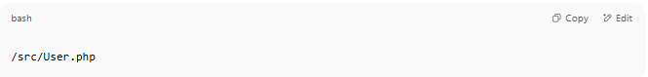
/src/User.php

Composer will autoload it when you run:
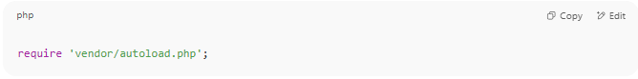
require 'vendor/autoload.php';

✔ Recommended:
If you're building any project with custom classes, keep the default:
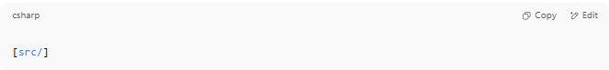
[src/]

❌ To skip:
If you're not using object-oriented PHP or classes:
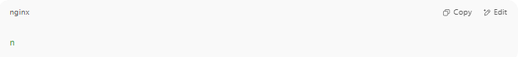
n

You can always add it later manually in composer.json.

📌 Summary Example:
Your composer.json will include:
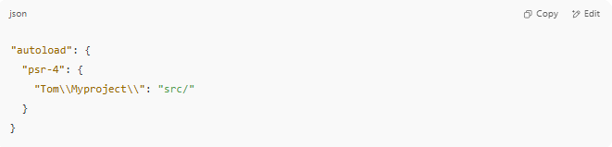
"autoload": {
"psr-4": {
"Tom\\Myproject\\": "src/"
}
}

10. 🟢 Next Step
# Source: AI Source: Provided by: [Data Path: Persons Table -> ID Column: 1, Name_En Column: Motasem Essam] -> From: [Chatgpt (GPT‑5 Mini)] on [1/26/2026]
After you type:
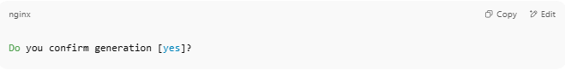
Do you confirm generation [yes]?

Type:

yes

Then run:
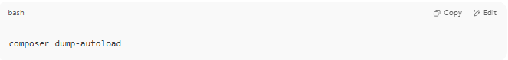
composer dump-autoload

This command will generate the vendor/ folder and the autoloader.

Example
# Source: AI Source: Provided by: [Data Path: Persons Table -> ID Column: 1, Name_En Column: Motasem Essam] -> From: [Chatgpt (GPT‑5 Mini)] on [1/26/2026]
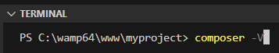
composer -V
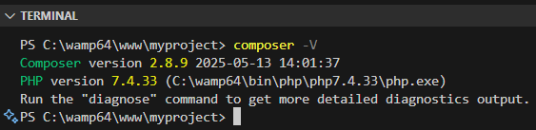
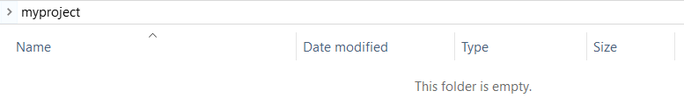
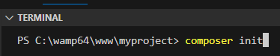
composer init
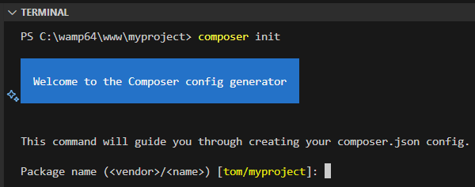
Click enter
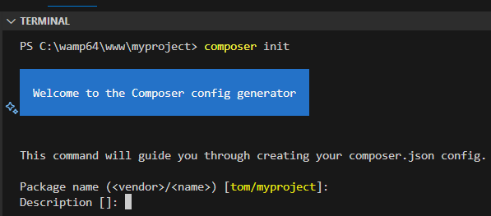
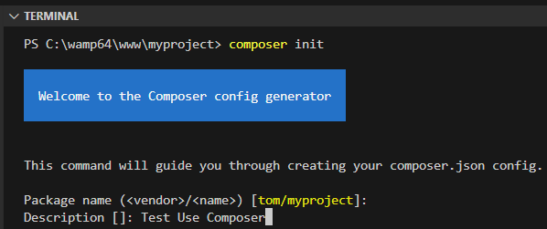
Test use Composer
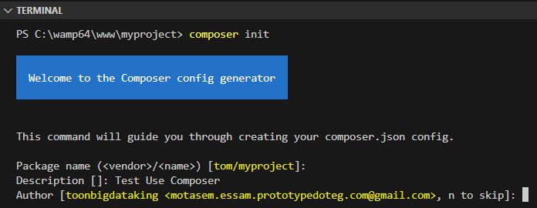
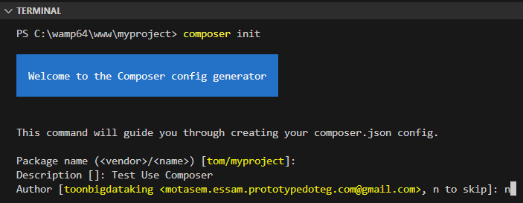
n
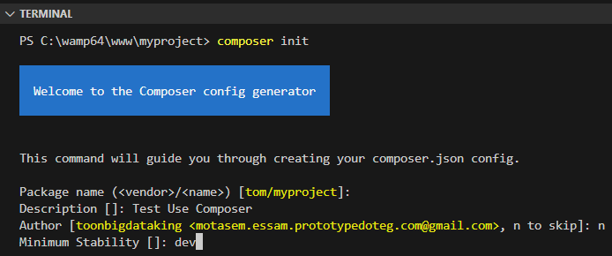
dev

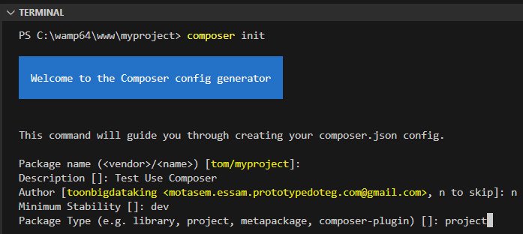
project

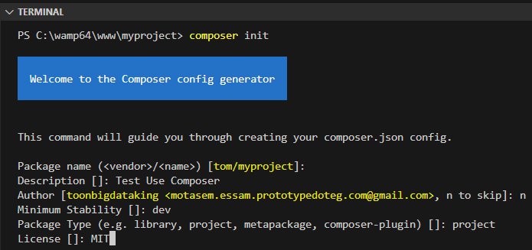
MIT

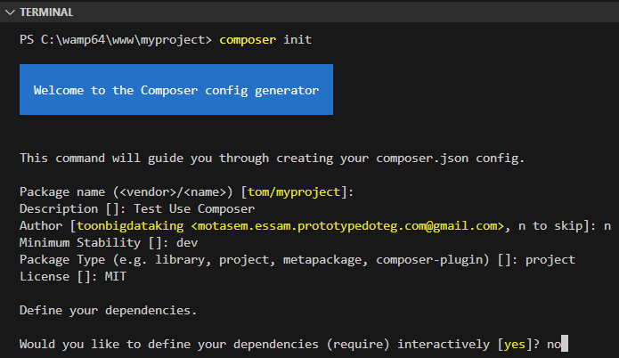
no
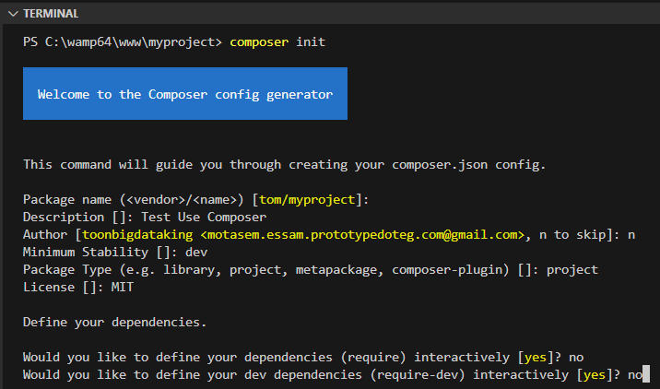
no
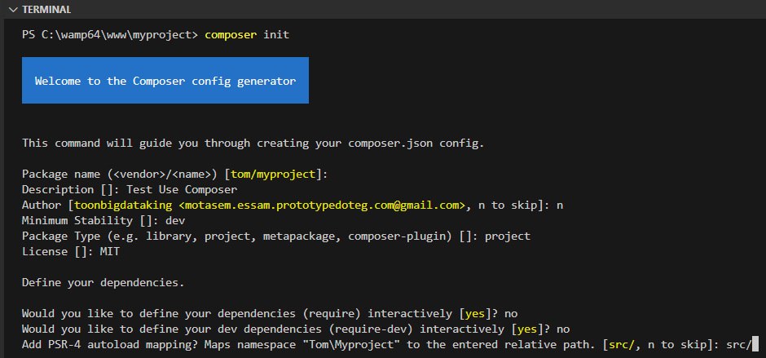
src/
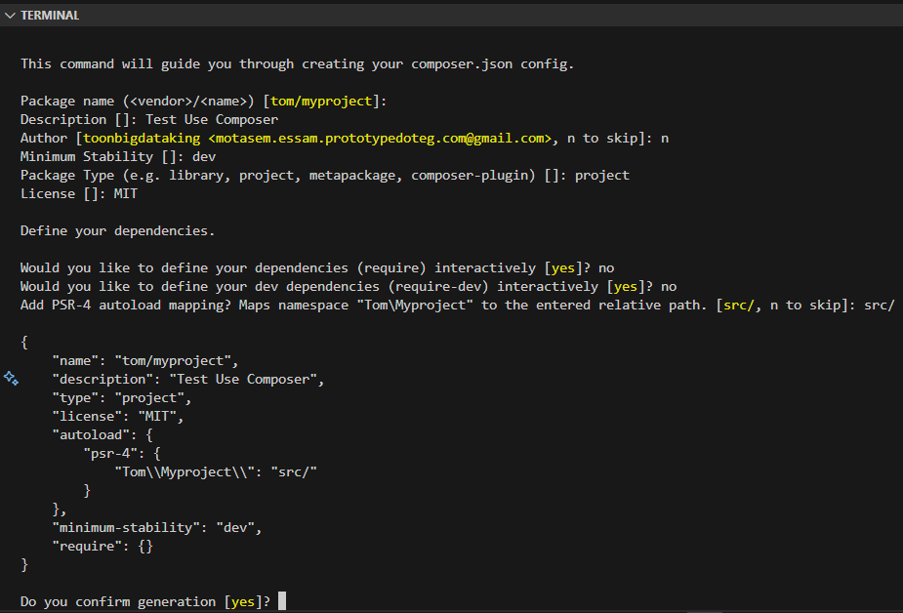
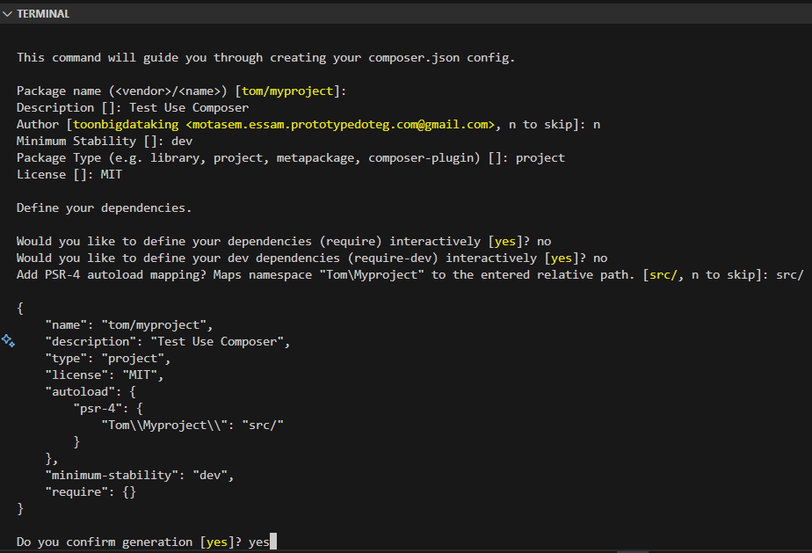
yes
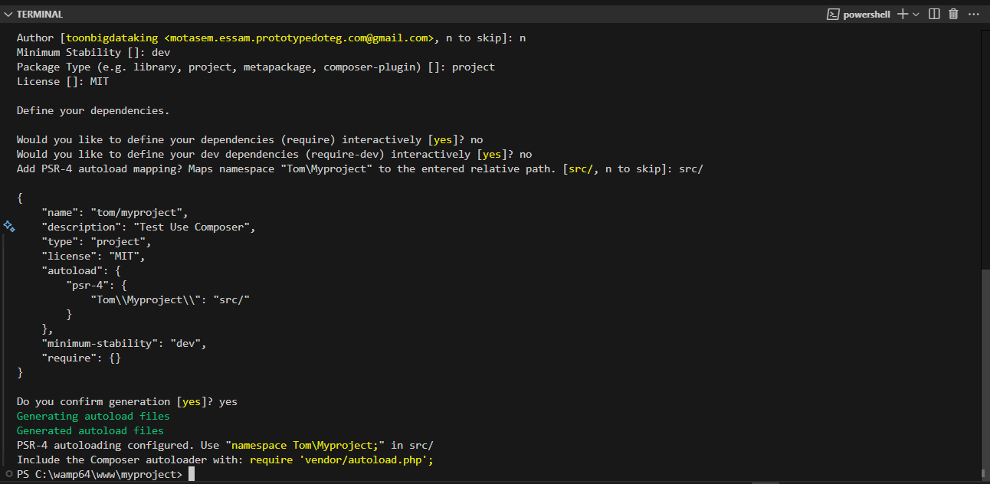
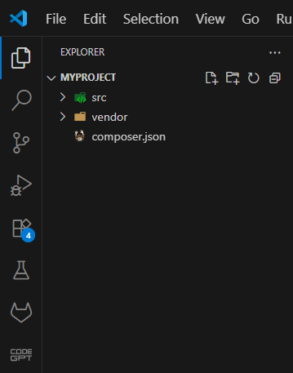
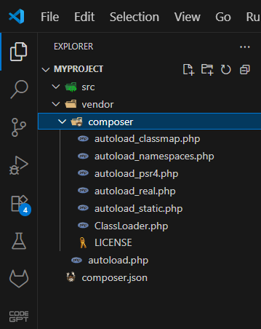

Change compose info After Using composer init

1-🔧 How to Change Project Name
# Source: AI Source: Provided by: [Data Path: Persons Table -> ID Column: 1, Name_En Column: Motasem Essam] -> From: [Chatgpt (GPT‑5 Mini)] on [1/26/2026]
If you used composer init and want to rename your PHP project, you can easily do it by editing your composer.json file manually.

📝 Step-by-Step Instructions

✅ 1. Open composer.json
# Source: AI Source: Provided by: [Data Path: Persons Table -> ID Column: 1, Name_En Column: Motasem Essam] -> From: [Chatgpt (GPT‑5 Mini)] on [1/26/2026]
Locate this section (usually near the top):
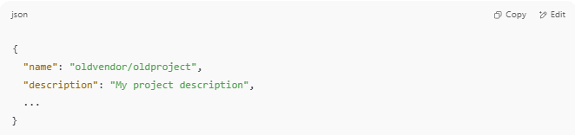
{
"name": "oldvendor/oldproject",
"description": "My project description",
...
}

✏️ 2. Change the "name" Field
# Source: AI Source: Provided by: [Data Path: Persons Table -> ID Column: 1, Name_En Column: Motasem Essam] -> From: [Chatgpt (GPT‑5 Mini)] on [1/26/2026]
Update it to your new project name. Use the format:
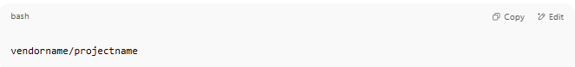
vendorname/projectname

For example:
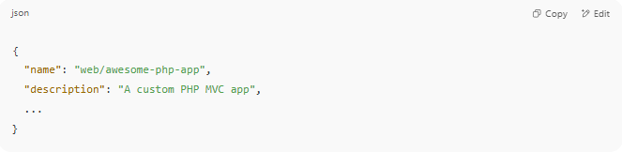
{
"name": "web/awesome-php-app",
"description": "A custom PHP MVC app",
...
}

🔹 vendorname = your GitHub username or org (if applicable)
🔹 projectname = your new project folder/repo name

🔄 3. (Optional) Rename the Folder
# Source: AI Source: Provided by: [Data Path: Persons Table -> ID Column: 1, Name_En Column: Motasem Essam] -> From: [Chatgpt (GPT‑5 Mini)] on [1/26/2026]
If your folder on disk is named incorrectly, rename it in your OS:
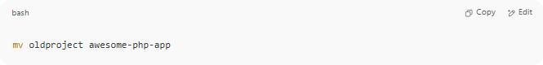
mv oldproject awesome-php-app

Or in Windows: right-click → Rename.

🔁 4. (Optional) Update Autoload Namespace
# Source: AI Source: Provided by: [Data Path: Persons Table -> ID Column: 1, Name_En Column: Motasem Essam] -> From: [Chatgpt (GPT‑5 Mini)] on [1/26/2026]
If you also want to update the PHP namespace (used in src/), edit this section:
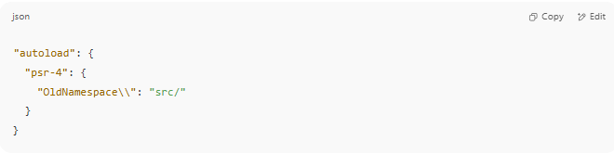
"autoload": {
"psr-4": {
"OldNamespace\\": "src/"
}
}

➡ Change it to your new namespace:
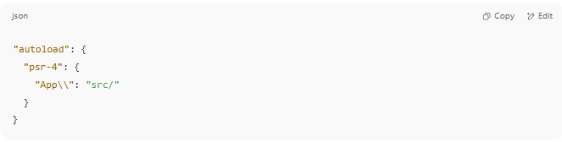
"autoload": {
"psr-4": {
"App\\": "src/"
}
}

Then re-run:
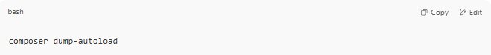
composer dump-autoload

📦 Final composer.json Example
# Source: AI Source: Provided by: [Data Path: Persons Table -> ID Column: 1, Name_En Column: Motasem Essam] -> From: [Chatgpt (GPT‑5 Mini)] on [1/26/2026]
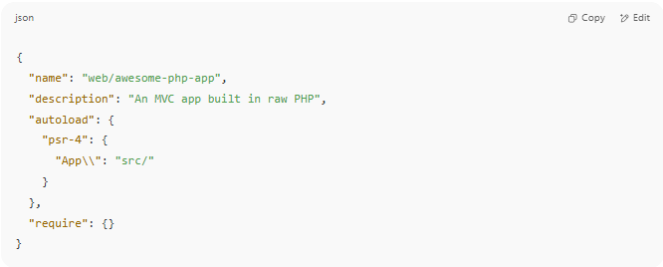

{
"name": "web/awesome-php-app",
"description": "An MVC app built in raw PHP",
"autoload": {
"psr-4": {
"App\\": "src/"
}
},
"require": {}
}

✅ Summary
# Source: AI Source: Provided by: [Data Path: Persons Table -> ID Column: 1, Name_En Column: Motasem Essam] -> From: [Chatgpt (GPT‑5 Mini)] on [1/26/2026]
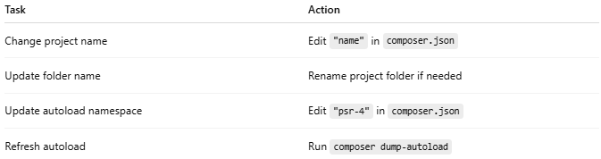
Task | Action
Change project name | Edit "name" in composer.json
Update folder name | Rename project folder if needed
Update autoload namespace | Edit "psr-4" in composer.json
Refresh autoload | Run composer dump-autoload

2-🔧 How to Change Project description
# Source: AI Source: Provided by: [Data Path: Persons Table -> ID Column: 1, Name_En Column: Motasem Essam] -> From: [Chatgpt (GPT‑5 Mini)] on [1/26/2026]
You can easily change the project description by editing the composer.json file.

📝 Step-by-Step Instructions

✅ 1. Open composer.json
# Source: AI Source: Provided by: [Data Path: Persons Table -> ID Column: 1, Name_En Column: Motasem Essam] -> From: [Chatgpt (GPT‑5 Mini)] on [1/26/2026]
Find the line that looks like this:
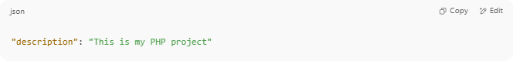
"description": "This is my PHP project"

✏️ 2. Change It to a New Description
# Source: AI Source: Provided by: [Data Path: Persons Table -> ID Column: 1, Name_En Column: Motasem Essam] -> From: [Chatgpt (GPT‑5 Mini)] on [1/26/2026]
Just edit the value of the "description" key:
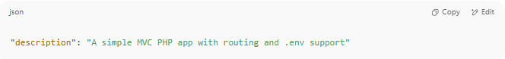
"description": "A simple MVC PHP app with routing and .env support"

✅ You can write anything here — it's for documentation purposes (and used if you publish the package on Packagist or GitHub).

🔄 3. Save the File
# Source: AI Source: Provided by: [Data Path: Persons Table -> ID Column: 1, Name_En Column: Motasem Essam] -> From: [Chatgpt (GPT‑5 Mini)] on [1/26/2026]
No need to run any Composer command after editing the description. It’s just metadata.

📦 Example composer.json (After Update)
# Source: AI Source: Provided by: [Data Path: Persons Table -> ID Column: 1, Name_En Column: Motasem Essam] -> From: [Chatgpt (GPT‑5 Mini)] on [1/26/2026]
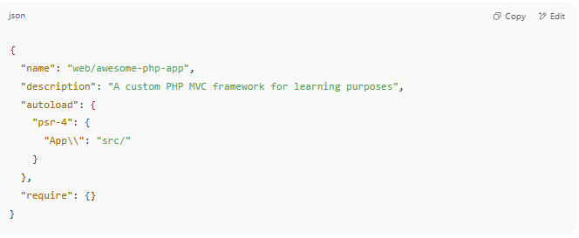

{
"name": "web/awesome-php-app",
"description": "A custom PHP MVC framework for learning purposes",
"autoload": {
"psr-4": {
"App\\": "src/"
}
},
"require": {}
}

✅ Summary
# Source: AI Source: Provided by: [Data Path: Persons Table -> ID Column: 1, Name_En Column: Motasem Essam] -> From: [Chatgpt (GPT‑5 Mini)] on [1/26/2026]
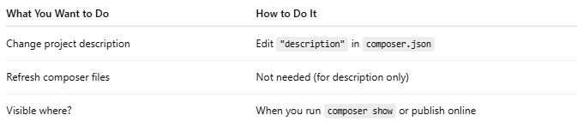

What You Want to Do | How to Do It
Change project description | Edit "description" in composer.json
Refresh composer files | Not needed (for description only)
Visible where? | When you run composer show or publish online

3-🔧 How to Change "authors"
# Source: AI Source: Provided by: [Data Path: Persons Table -> ID Column: 1, Name_En Column: Motasem Essam] -> From: [Chatgpt (GPT‑5 Mini)] on [1/26/2026]
If you already used composer init and want to update the author info, it’s very simple — just manually edit the composer.json file.

✅ Step-by-Step Guide

1. 📝 Open composer.json
# Source: AI Source: Provided by: [Data Path: Persons Table -> ID Column: 1, Name_En Column: Motasem Essam] -> From: [Chatgpt (GPT‑5 Mini)] on [1/26/2026]
Look for this section:
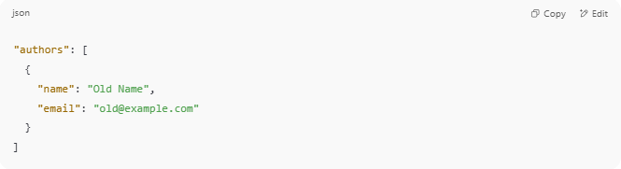
"authors": [
{
"name": "Old Name",
"email": "old@example.com"
}
]

2. ✏️ Edit the Author Info
# Source: AI Source: Provided by: [Data Path: Persons Table -> ID Column: 1, Name_En Column: Motasem Essam] -> From: [Chatgpt (GPT‑5 Mini)] on [1/26/2026]
Change it to your updated name, email, role, or homepage:
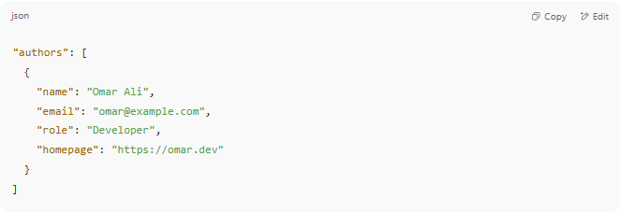
"authors": [
{
"name": "Omar Ali",
"email": "omar@example.com",
"role": "Developer",
"homepage": "https://omar.dev"
}
]

✅ You can add multiple authors as well!

3. 💾 Save the File
# Source: AI Source: Provided by: [Data Path: Persons Table -> ID Column: 1, Name_En Column: Motasem Essam] -> From: [Chatgpt (GPT‑5 Mini)] on [1/26/2026]
No additional command is needed — Composer reads composer.json directly when running commands.

📦 Example Full Section
# Source: AI Source: Provided by: [Data Path: Persons Table -> ID Column: 1, Name_En Column: Motasem Essam] -> From: [Chatgpt (GPT‑5 Mini)] on [1/26/2026]
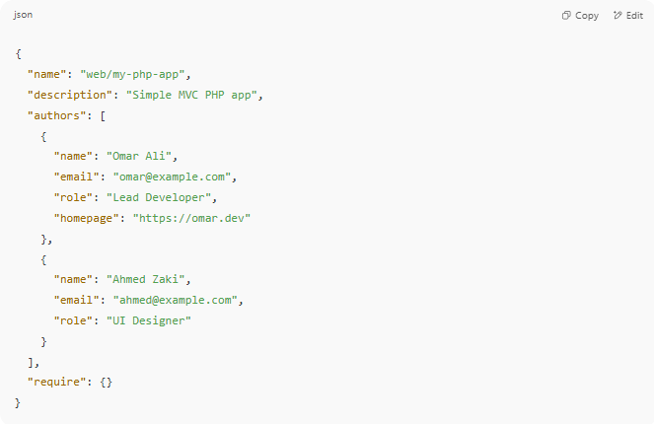
{
"name": "web/my-php-app",
"description": "Simple MVC PHP app",
"authors": [
{
"name": "Omar Ali",
"email": "omar@example.com",
"role": "Lead Developer",
"homepage": "https://omar.dev"
},
{
"name": "Ahmed Zaki",
"email": "ahmed@example.com",
"role": "UI Designer"
}
],
"require": {}
}

🔍 How to View Author Info
# Source: AI Source: Provided by: [Data Path: Persons Table -> ID Column: 1, Name_En Column: Motasem Essam] -> From: [Chatgpt (GPT‑5 Mini)] on [1/26/2026]
You can confirm your authors using:
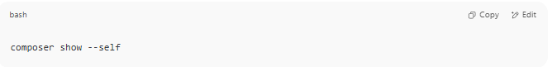
composer show --self

It will show:
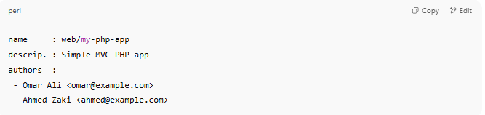
name : web/my-php-app
descrip. : Simple MVC PHP app
authors :
- Omar Ali <omar@example.com>
- Ahmed Zaki <ahmed@example.com>

✅ Summary
# Source: AI Source: Provided by: [Data Path: Persons Table -> ID Column: 1, Name_En Column: Motasem Essam] -> From: [Chatgpt (GPT‑5 Mini)] on [1/26/2026]
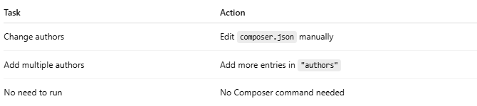

Task | Action
Change authors | Edit composer.json manually
Add multiple authors | Add more entries in "authors"
No need to run | No Composer command needed

4-🔧How to Change Minimum Stability
# Source: AI Source: Provided by: [Data Path: Persons Table -> ID Column: 1, Name_En Column: Motasem Essam] -> From: [Chatgpt (GPT‑5 Mini)] on [1/26/2026]
The minimum-stability option in composer.json controls what type of package versions Composer will allow (stable, beta, dev, etc.).

✅ Step-by-Step: Change minimum-stability
# Source: AI Source: Provided by: [Data Path: Persons Table -> ID Column: 1, Name_En Column: Motasem Essam] -> From: [Chatgpt (GPT‑5 Mini)] on [1/26/2026]
1📝 Open composer.json
Look for (or add) this line:
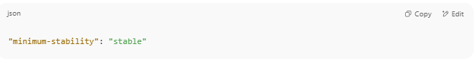
"minimum-stability": "stable"

If it’s not there, you can add it anywhere in the root of the JSON file.

🎯 Valid Stability Levels (from most stable to least):
# Source: AI Source: Provided by: [Data Path: Persons Table -> ID Column: 1, Name_En Column: Motasem Essam] -> From: [Chatgpt (GPT‑5 Mini)] on [1/26/2026]
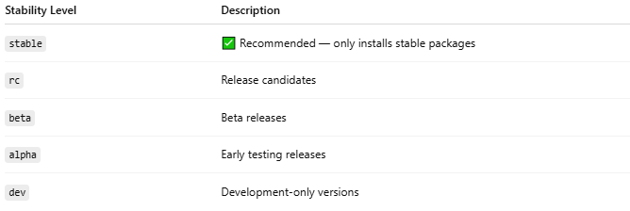
Stability Level | Description
stable | ✅ Recommended — only installs stable packages
rc | Release candidates
beta | Beta releases
alpha | Early testing releases
dev | Development-only versions

🧾 Example: Allow Beta Packages
# Source: AI Source: Provided by: [Data Path: Persons Table -> ID Column: 1, Name_En Column: Motasem Essam] -> From: [Chatgpt (GPT‑5 Mini)] on [1/26/2026]
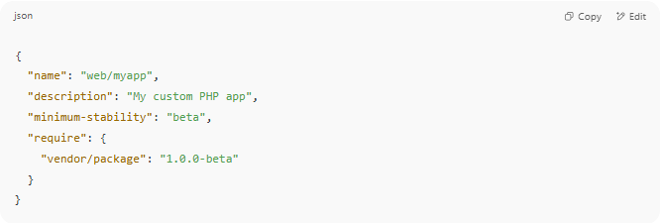
{
"name": "web/myapp",
"description": "My custom PHP app",
"minimum-stability": "beta",
"require": {
"vendor/package": "1.0.0-beta"
}
}

🔐 Optional: Use "prefer-stable": true
# Source: AI Source: Provided by: [Data Path: Persons Table -> ID Column: 1, Name_En Column: Motasem Essam] -> From: [Chatgpt (GPT‑5 Mini)] on [1/26/2026]
This means:
"Try to install stable versions if possible, but allow less stable ones if needed."
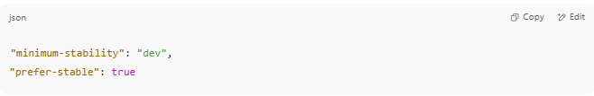
"minimum-stability": "dev",
"prefer-stable": true

🧠 When You Might Need to Change It
# Source: AI Source: Provided by: [Data Path: Persons Table -> ID Column: 1, Name_En Column: Motasem Essam] -> From: [Chatgpt (GPT‑5 Mini)] on [1/26/2026]
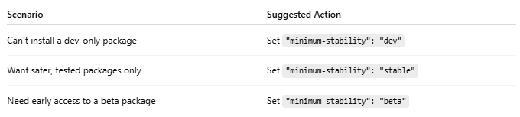
Scenario | Suggested Action
Can't install a dev-only package | Set "minimum-stability": "dev"
Want safer, tested packages only | Set "minimum-stability": "stable"
Need early access to a beta package | Set "minimum-stability": "beta"

🔄 After You Change It
# Source: AI Source: Provided by: [Data Path: Persons Table -> ID Column: 1, Name_En Column: Motasem Essam] -> From: [Chatgpt (GPT‑5 Mini)] on [1/26/2026]
Run:
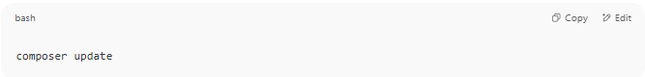
composer update

This will re-evaluate dependencies using the new stability rule.

✅ Summary
# Source: AI Source: Provided by: [Data Path: Persons Table -> ID Column: 1, Name_En Column: Motasem Essam] -> From: [Chatgpt (GPT‑5 Mini)] on [1/26/2026]
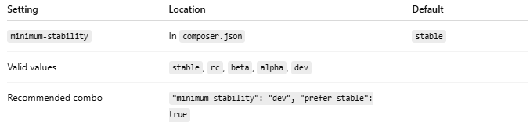
Setting | Location | Default
minimum-stability | In composer.json | stable
Valid values | stable, rc, beta, alpha, dev
Recommended combo | "minimum-stability": "dev", "prefer-stable": true

5-🔧How to Change Package Type
# Source: AI Source: Provided by: [Data Path: Persons Table -> ID Column: 1, Name_En Column: Motasem Essam] -> From: [Chatgpt (GPT‑5 Mini)] on [1/26/2026]
The "type" field in composer.json defines what kind of package your project is — for example, a library, project, composer-plugin, etc.

✅ Step-by-Step: Change the Package Type
# Source: AI Source: Provided by: [Data Path: Persons Table -> ID Column: 1, Name_En Column: Motasem Essam] -> From: [Chatgpt (GPT‑5 Mini)] on [1/26/2026]
📝 Open composer.json
Look for (or add) the type field:
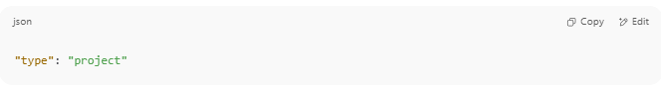
"type": "project"

If it's missing, you can safely add it near the top of the file.

🎯 Common Composer Package Types
# Source: AI Source: Provided by: [Data Path: Persons Table -> ID Column: 1, Name_En Column: Motasem Essam] -> From: [Chatgpt (GPT‑5 Mini)] on [1/26/2026]
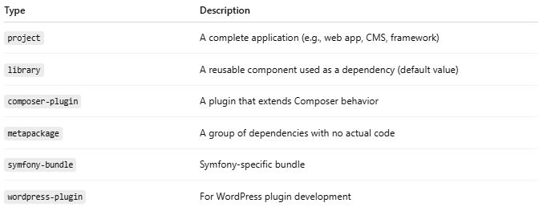

Type | Description
project | A complete application (e.g., web app, CMS, framework)
library | A reusable component used as a dependency (default value)
composer-plugin | A plugin that extends Composer behavior
metapackage | A group of dependencies with no actual code
symfony-bundle | Symfony-specific bundle
wordpress-plugin | For WordPress plugin development

📄 Example Before
# Source: AI Source: Provided by: [Data Path: Persons Table -> ID Column: 1, Name_En Column: Motasem Essam] -> From: [Chatgpt (GPT‑5 Mini)] on [1/26/2026]
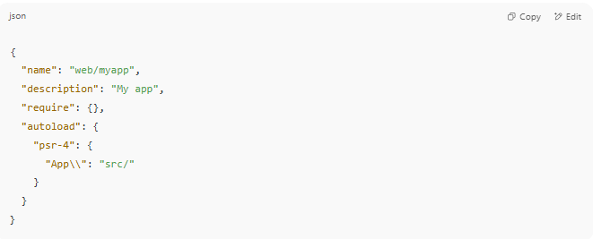

{
"name": "web/myapp",
"description": "My app",
"require": {},
"autoload": {
"psr-4": {
"App\\": "src/"
}
}
}

✅ Example After Adding Type
# Source: AI Source: Provided by: [Data Path: Persons Table -> ID Column: 1, Name_En Column: Motasem Essam] -> From: [Chatgpt (GPT‑5 Mini)] on [1/26/2026]
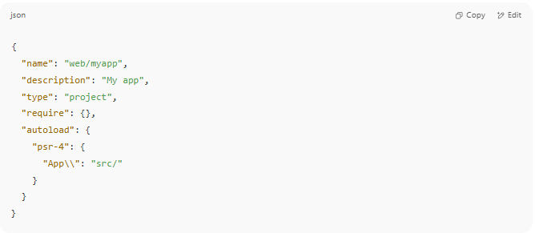
{
"name": "web/myapp",
"description": "My app",
"type": "project",
"require": {},
"autoload": {
"psr-4": {
"App\\": "src/"
}
}
}

🧠 When Should You Change the Type?
# Source: AI Source: Provided by: [Data Path: Persons Table -> ID Column: 1, Name_En Column: Motasem Essam] -> From: [Chatgpt (GPT‑5 Mini)] on [1/26/2026]
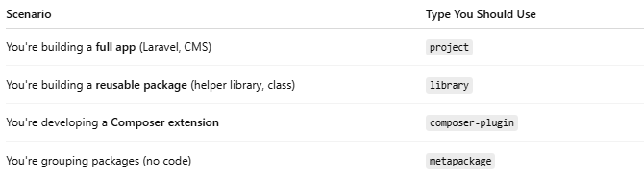

Scenario | Type You Should Use
You're building a full app (Laravel, CMS) | project
You're building a reusable package (helper library, class) | library
You're developing a Composer extension | composer-plugin
You're grouping packages (no code) | metapackage

⚠️ Note:
# Source: AI Source: Provided by: [Data Path: Persons Table -> ID Column: 1, Name_En Column: Motasem Essam] -> From: [Chatgpt (GPT‑5 Mini)] on [1/26/2026]
- The "type" does not affect installation unless you're writing a custom Composer plugin or using install path logic.
- It's mostly for organization, clarity, and tooling support (e.g., Symfony, Packagist).

✅ Summary
# Source: AI Source: Provided by: [Data Path: Persons Table -> ID Column: 1, Name_En Column: Motasem Essam] -> From: [Chatgpt (GPT‑5 Mini)] on [1/26/2026]
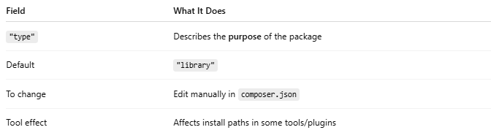
Field | What It Does
"type" | Describes the purpose of the package
Default | "library"
To change | Edit manually in composer.json
Tool effect | Affects install paths in some tools/plugins

6-🔧How to Change license Type
# Source: AI Source: Provided by: [Data Path: Persons Table -> ID Column: 1, Name_En Column: Motasem Essam] -> From: [Chatgpt (GPT‑5 Mini)] on [1/26/2026]
The license field in your composer.json tells others how they are allowed to use, share, and modify your code. If you want to update it after initializing your project with Composer, here's how to do it.

✅ Step-by-Step: Change License Type

1. 📝 Open composer.json
# Source: AI Source: Provided by: [Data Path: Persons Table -> ID Column: 1, Name_En Column: Motasem Essam] -> From: [Chatgpt (GPT‑5 Mini)] on [1/26/2026]
Look for the license field:
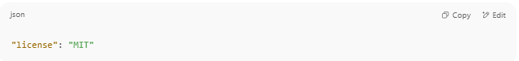
"license": "MIT"

If it doesn’t exist, you can add it manually near the top of the file.

2. ✏️ Replace or Update It
# Source: AI Source: Provided by: [Data Path: Persons Table -> ID Column: 1, Name_En Column: Motasem Essam] -> From: [Chatgpt (GPT‑5 Mini)] on [1/26/2026]
Change it to the license that matches your intent. Example:
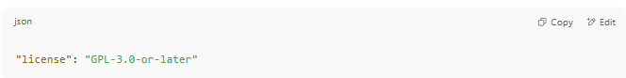
"license": "GPL-3.0-or-later"

Or:
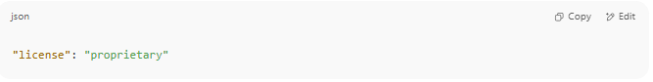
"license": "proprietary"

📋 Common License Options
# Source: AI Source: Provided by: [Data Path: Persons Table -> ID Column: 1, Name_En Column: Motasem Essam] -> From: [Chatgpt (GPT‑5 Mini)] on [1/26/2026]
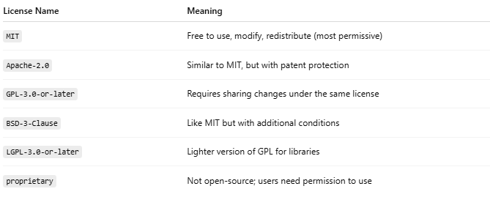
License Name | Meaning
MIT | Free to use, modify, redistribute (most permissive)
Apache-2.0 | Similar to MIT, but with patent protection
GPL-3.0-or-later | Requires sharing changes under the same license
BSD-3-Clause | Like MIT but with additional conditions
LGPL-3.0-or-later | Lighter version of GPL for libraries
proprietary | Not open-source; users need permission to use
You can check valid license identifiers at:
🔗 SPDX License List

📄 Example Before and After
# Source: AI Source: Provided by: [Data Path: Persons Table -> ID Column: 1, Name_En Column: Motasem Essam] -> From: [Chatgpt (GPT‑5 Mini)] on [1/26/2026]
Before:
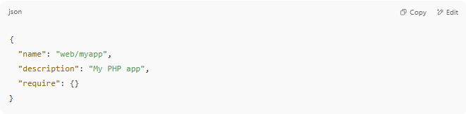
{
"name": "web/myapp",
"description": "My PHP app",
"require": {}
}

After:
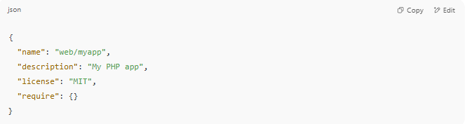
{
"name": "web/myapp",
"description": "My PHP app",
"license": "MIT",
"require": {}
}

🧠 When Should You Use proprietary?
# Source: AI Source: Provided by: [Data Path: Persons Table -> ID Column: 1, Name_En Column: Motasem Essam] -> From: [Chatgpt (GPT‑5 Mini)] on [1/26/2026]
Use "proprietary" if:
- You don’t want to share your code
- You’re working on a private business project
- You want to restrict distribution

✅ Summary
# Source: AI Source: Provided by: [Data Path: Persons Table -> ID Column: 1, Name_En Column: Motasem Essam] -> From: [Chatgpt (GPT‑5 Mini)] on [1/26/2026]
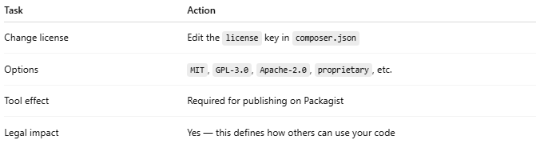

Task | Action
Change license | Edit the license key in composer.json
Options | MIT, GPL-3.0, Apache-2.0, proprietary, etc.
Tool effect | Required for publishing on Packagist
Legal impact | Yes — this defines how others can use your code

7-🔧How to Change PSR-4 Autoload Mapping
# Source: AI Source: Provided by: [Data Path: Persons Table -> ID Column: 1, Name_En Column: Motasem Essam] -> From: [Chatgpt (GPT‑5 Mini)] on [1/26/2026]
When you run composer init, you may define PSR-4 autoloading for your PHP classes. If you want to change or update the mapping later, you can easily do that by editing composer.json.

📦 What is PSR-4 Autoload Mapping?
# Source: AI Source: Provided by: [Data Path: Persons Table -> ID Column: 1, Name_En Column: Motasem Essam] -> From: [Chatgpt (GPT‑5 Mini)] on [1/26/2026]
PSR-4 maps namespaces to folders, so Composer can autoload classes automatically when you use them.
Example:
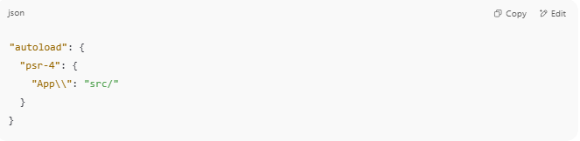
"autoload": {
"psr-4": {
"App\\": "src/"
}
}

This tells Composer:
🔁 App\Controllers\UserController → src/Controllers/UserController.php

✅ How to Change It

✏️ Step 1: Open composer.json
# Source: AI Source: Provided by: [Data Path: Persons Table -> ID Column: 1, Name_En Column: Motasem Essam] -> From: [Chatgpt (GPT‑5 Mini)] on [1/26/2026]
Look for the "autoload" section:
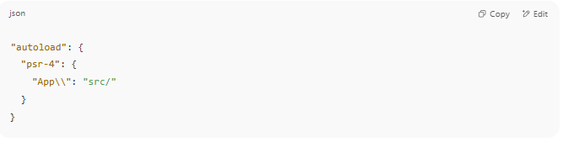
"autoload": {
"psr-4": {
"App\\": "src/"
}
}

✏️ Step 2: Change the Namespace or Folder
# Source: AI Source: Provided by: [Data Path: Persons Table -> ID Column: 1, Name_En Column: Motasem Essam] -> From: [Chatgpt (GPT‑5 Mini)] on [1/26/2026]
For example, change the namespace from App\\ to MyProject\\, and the folder to app/:
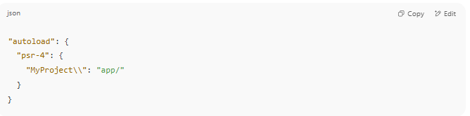
"autoload": {
"psr-4": {
"MyProject\\": "app/"
}
}

You can also add multiple mappings:
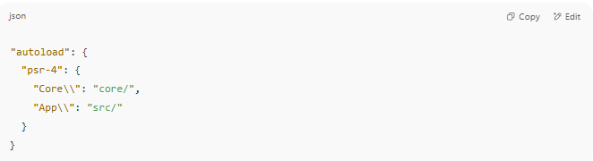
"autoload": {
"psr-4": {
"Core\\": "core/",
"App\\": "src/"
}
}

🔁 Step 3: Run composer dump-autoload
# Source: AI Source: Provided by: [Data Path: Persons Table -> ID Column: 1, Name_En Column: Motasem Essam] -> From: [Chatgpt (GPT‑5 Mini)] on [1/26/2026]
After changing the mapping, regenerate the autoload files:
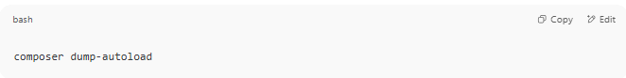
composer dump-autoload

This updates the vendor/autoload.php and makes Composer recognize your new mappings.

🧪 Step 4: Use the New Namespace in Your PHP Files
# Source: AI Source: Provided by: [Data Path: Persons Table -> ID Column: 1, Name_En Column: Motasem Essam] -> From: [Chatgpt (GPT‑5 Mini)] on [1/26/2026]
If you changed to MyProject\\, then your class should look like:
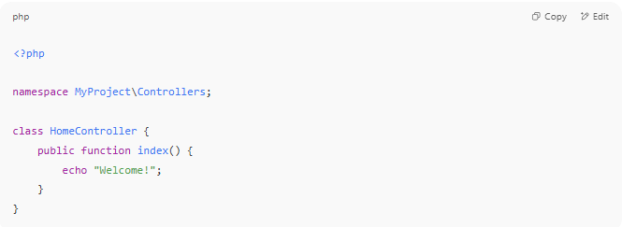
<?php

namespace MyProject\Controllers;

class HomeController {
public function index() {
echo "Welcome!";
}
}

And the file should be located at:
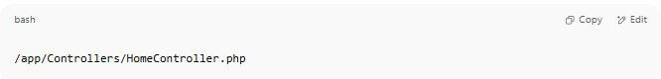
/app/Controllers/HomeController.php

✅ Summary
# Source: AI Source: Provided by: [Data Path: Persons Table -> ID Column: 1, Name_En Column: Motasem Essam] -> From: [Chatgpt (GPT‑5 Mini)] on [1/26/2026]
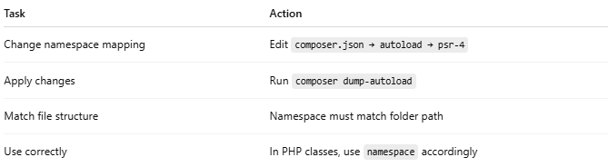
Task | Action
Change namespace mapping | Edit composer.json → autoload → psr-4
Apply changes | Run composer dump-autoload
Match file structure | Namespace must match folder path
Use correctly | In PHP classes, use namespace accordingly

